Fulfillment Configuration Approach Word

1. Fulfillment Configuration Approach

1.1 Fulfillment Configuration Approach
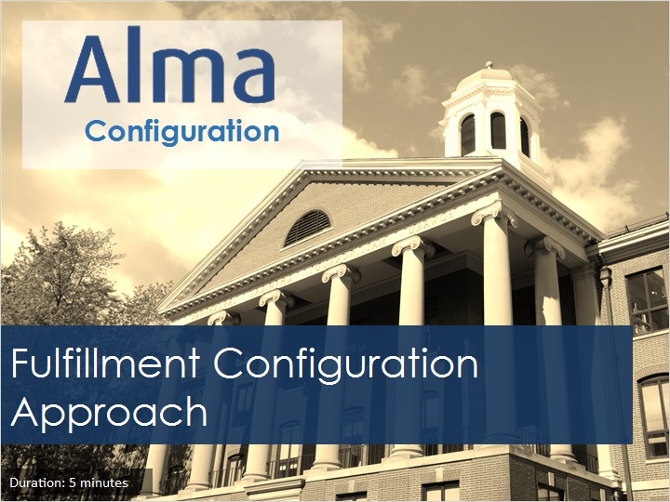
Notes:
Welcome to this session, Fulfillment Configuration Approach.

1.2 Objectives
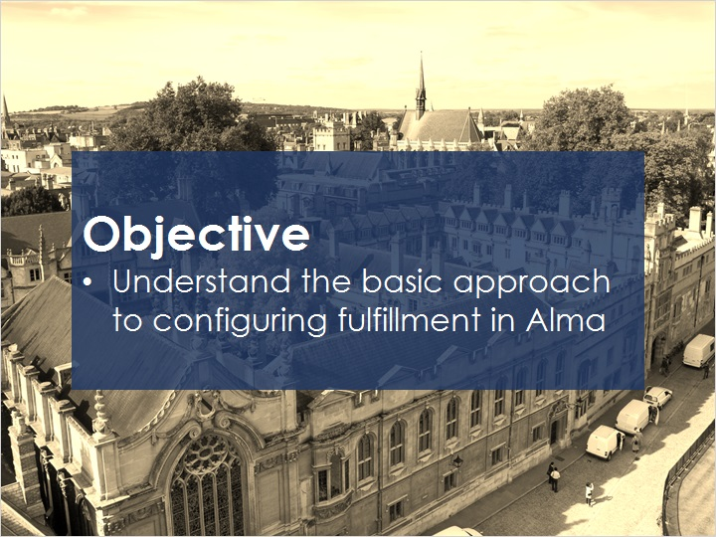
Notes:
In this session, you will learn the basic approach to configuring fulfillment in Alma.

1.3 Approach to Fulfillment
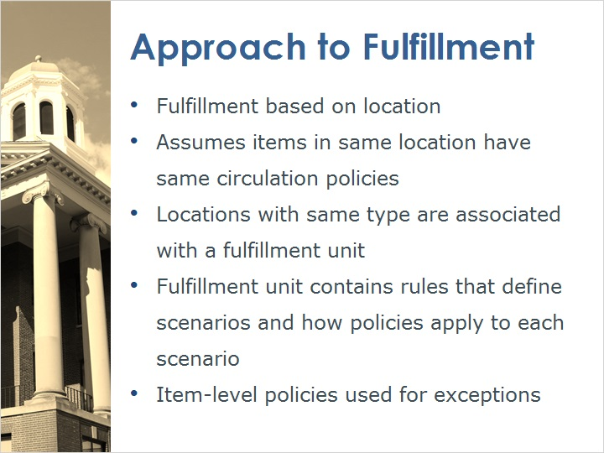
Notes:
Alma’s approach to fulfillment is different than in traditional ILS systems. Traditionally, fulfillment has been handled on an item-level basis in which each and every item receives a status or policy which, together with the patron status, is used to determine the applicable loan policies for each item.

Fulfillment configuration in Alma is based on location, and assumes that items in the same location circulate under more or less the same policies.

Locations of the same type are associated with a fulfillment unit. The fulfillment unit contains rules that define scenarios and the policies that will be applied to those scenarios. Typically, scenarios are defined according to user group.

In the event there are exceptions, Alma can use the item status to define circulation policies. But by default, all other items will circulate according to the policies defined for their location.

1.4 Advantages to Approach
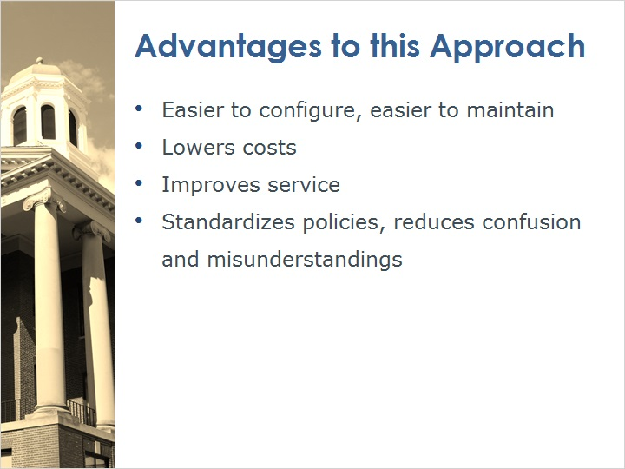
Notes:
By managing fulfillment on the location level, it is no longer necessary to maintain an item status on each and every item. On the contrary, item-level status should be maintained only on exceptional items. This approach is easier to configure and maintain, thus lowering operating costs. In addition, defining fulfillment policies according to location makes it easier for patrons to understand the terms of use, reducing confusion and misunderstandings.

1.5 Location Type Examples
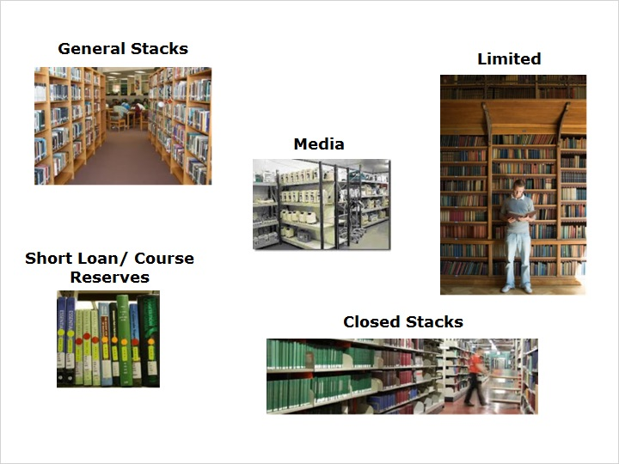
Notes:
Typically, a library has several different types of locations, such as general stacks, course reserves, media, etc., each with its own circulation policies.

1.6 Location Type = Fulfillment Unit
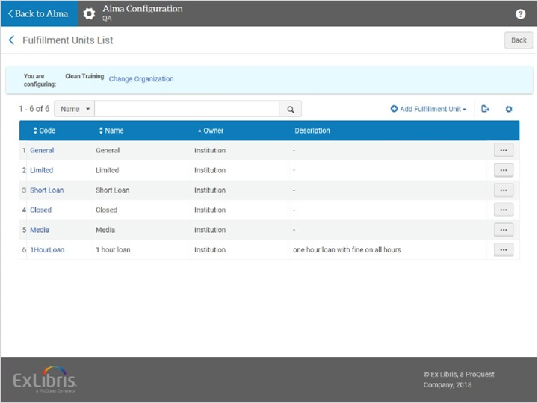
Notes:
A fulfillment unit is one or more physical locations within an institution that follow the same policies. Fulfillment units have Terms of Use (TOU) which define policies for patrons.

You may have several different fulfillment units, one for each location type. Here we see an example of fulfillment units configured in Alma.

And here we see the limited type locations that have been gathered together into the Limited fulfillment unit. Notice that locations of the same type, albeit from different libraries, are included in the fulfillment unit.

Fulfillment Unit Locations (Slide Layer)
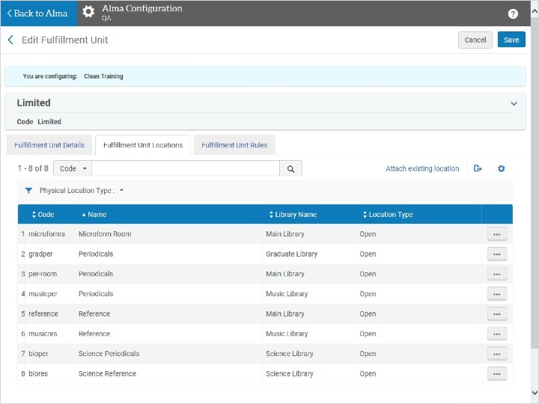

1.7 Fulfillment Unit Rules
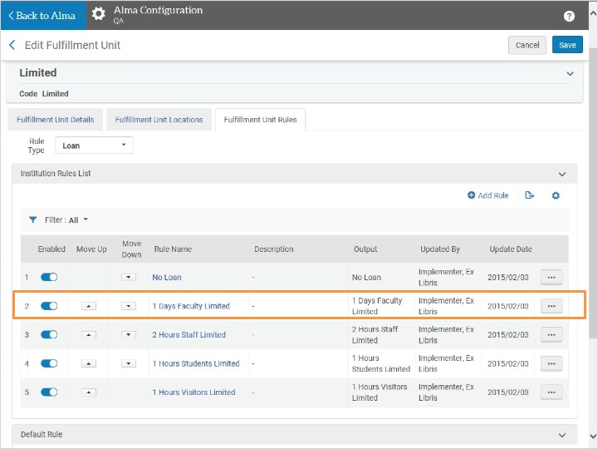
Notes:
A fulfillment unit also contains rules that will be applied to items in each of the locations associated with the fulfillment unit. These rules determine the circulation polices that will be applied to all items in that fulfillment unit.

Fulfillment unit rules are used to define a certain scenario and determine the circulation policies, or ‘terms of use’ that will be applied to that scenario. For example, a patron with user group ‘faculty’ wants to borrow a book from the limited stacks location.

Here we see a screen-shot of a fulfillment unit rule in Alma. The middle section describes the scenario, or input parameters of the rule. In this case, we have a patron with user group faculty.
The bottom section of the screen defines the terms of use that will be applied to a loan in this scenario.

Rules Editor (Slide Layer)
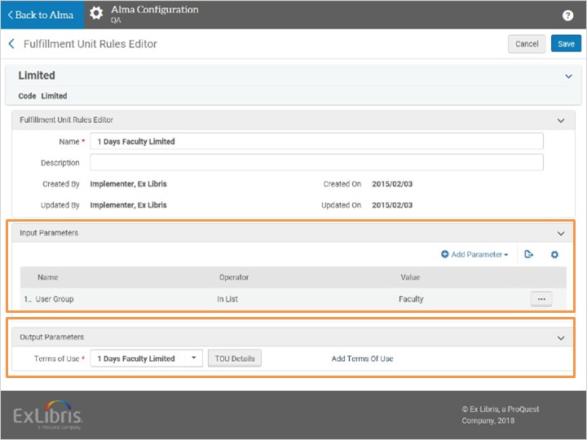

1.8 TOU Details (Loan)
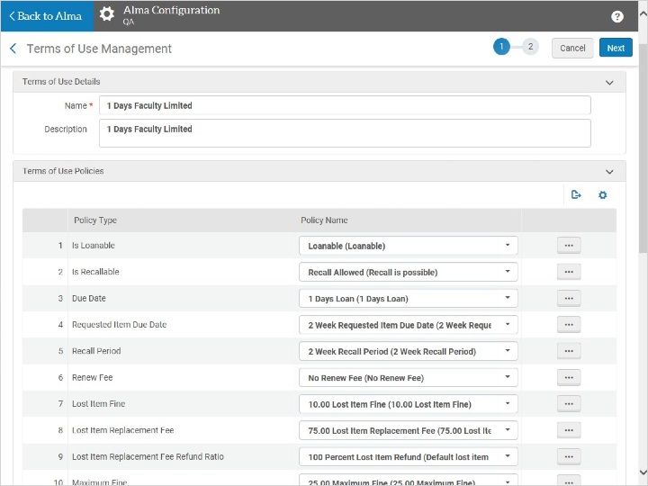
Notes:
Here we have the policies, or terms of use, that will be applied to this loan. The column on the left displays each of the policy types that relate to any loan, for example whether the item is loanable, what the due date is, if overdue fines apply, etc.

The column on the right contains the specific values for each policy type that will be applied to this loan.

1.9 TOU (Request)
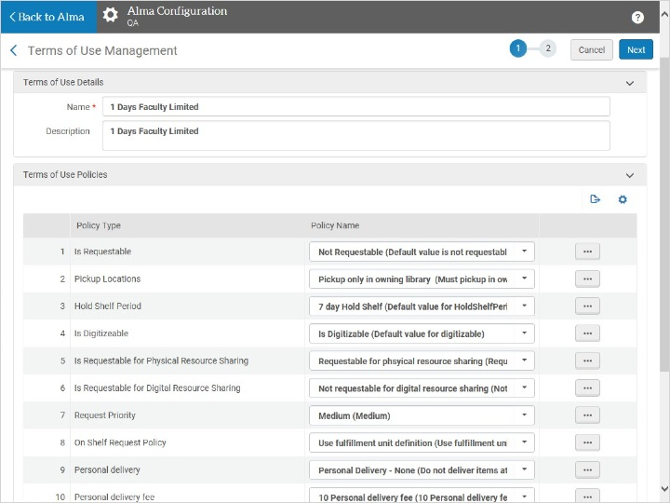
Notes:
Just as we have rules and terms of use for loans, there are rules and terms of use for requests. Here we see the policies that are applied to a patron hold request: whether the item may be requested, where the requested item may be picked up, and how long it will be kept on the hold shelf.

1.10 Fulfillment Unit Rules
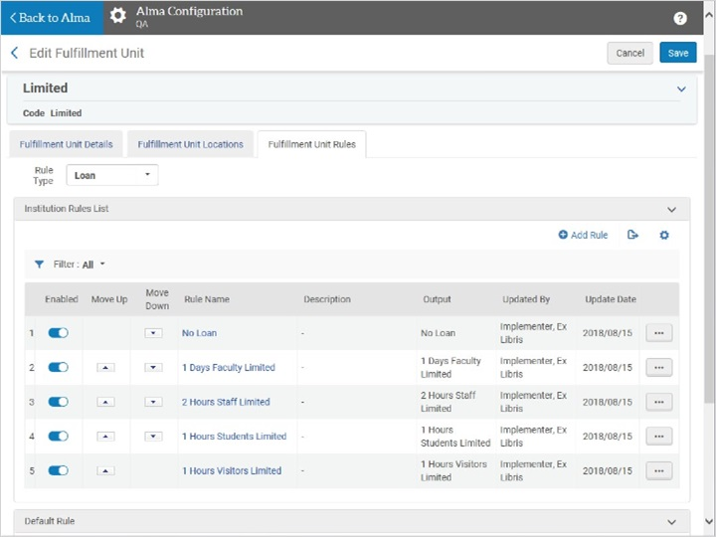
Notes:
Fulfillment units typically contain several different rules, each one defining a different scenario and the terms of use that will be applied in that scenario. These scenarios usually make reference to the patron’s user group. Rules may also make reference to item status, in case you have items that circulate differently than the majority of items in that location. Alma checks the rules from top to bottom and applies the first rule that fits.

1.11 Review
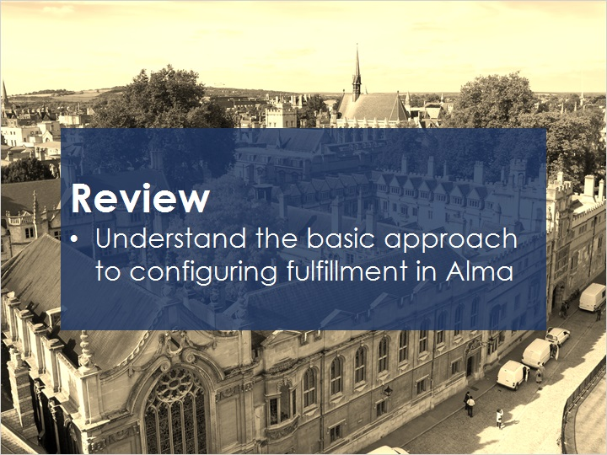
Notes:
Now that you’ve watched this session you should understand the basic approach to configuring fulfillment in Alma.

1.12 Thank You!
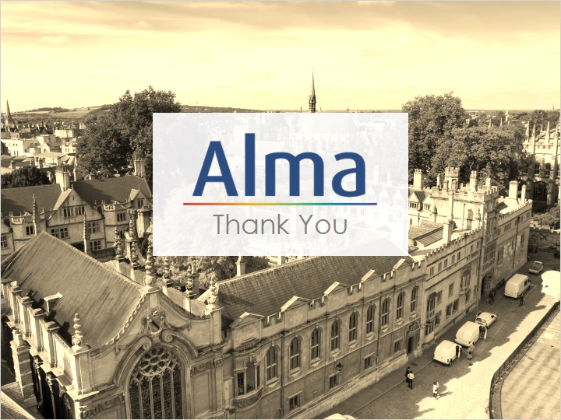
Notes:
Thank you for joining this session!

1.13 Copyrights

Notes:

