Alma Configuration Form

1. Alma Configuration Form

1.1 Configuration Form
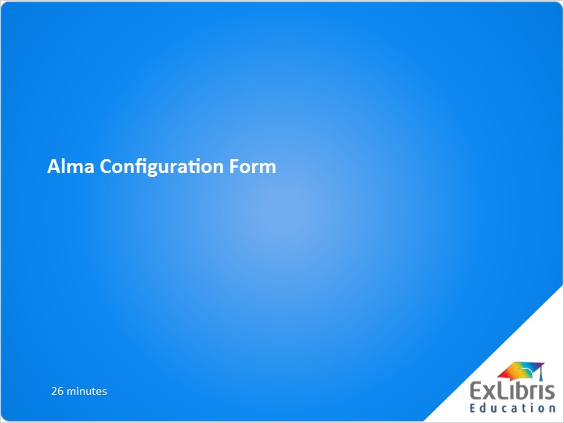
Notes:
Welcome. In this presentation, we will focus on the Alma Configuration Form.

1.2 Agenda
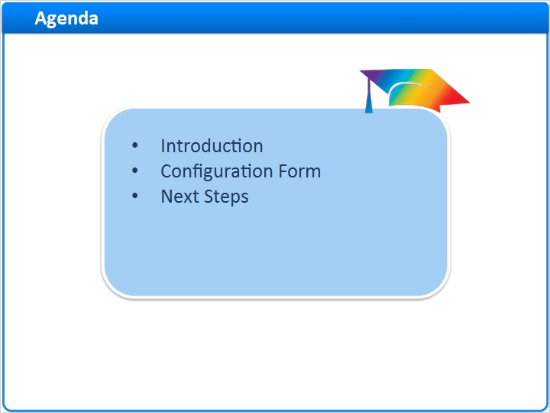
Notes:
After this session, you should be able to complete the configuration form on behalf of your institution. In addition, a live session will be scheduled to answer any questions you may have.

1.3 Introduction
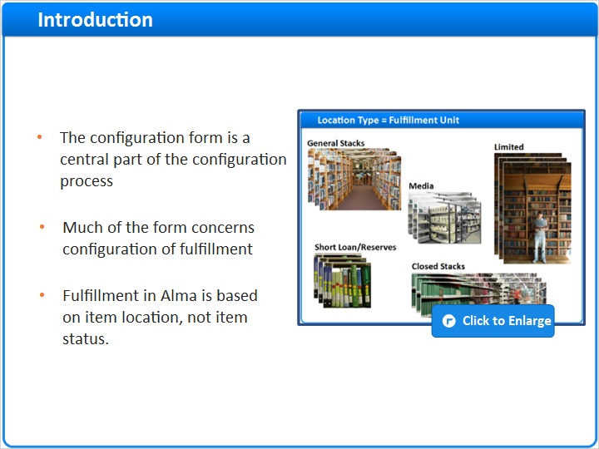
Notes:
In the Introduction to Alma Configuration presentation, we learned that:
The configuration form comprises the initial stage of the configuration process after the test migration of your data to Alma. Once your Alma environment is configured on the basis of your configuration form, modification of that configuration will be made in response to your testing and feedback.
Much of the configuration form concerns configuration of fulfillment;
Fulfillment in Alma is based on item location. Item status is used for exceptions. Alma gathers together all the locations of a given type into a Fulfillment Unit. A fulfillment unit also contains rules that determine the circulation polices that will be applied to all the items in all the locations in that fulfillment unit.

project-plan (Slide Layer)
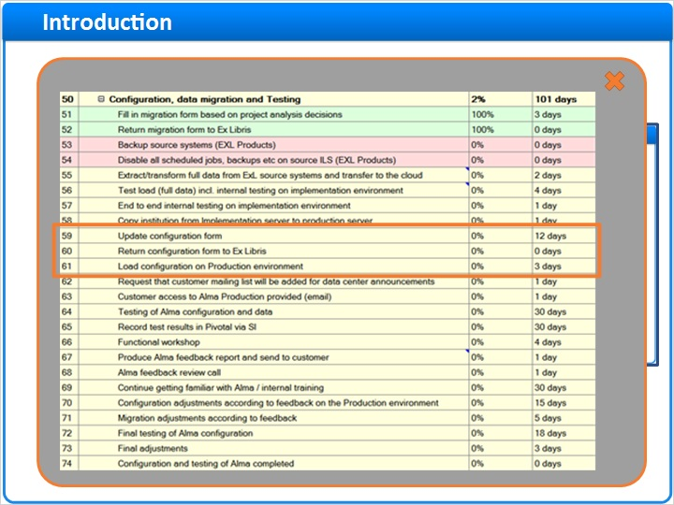

1.4 Documentation
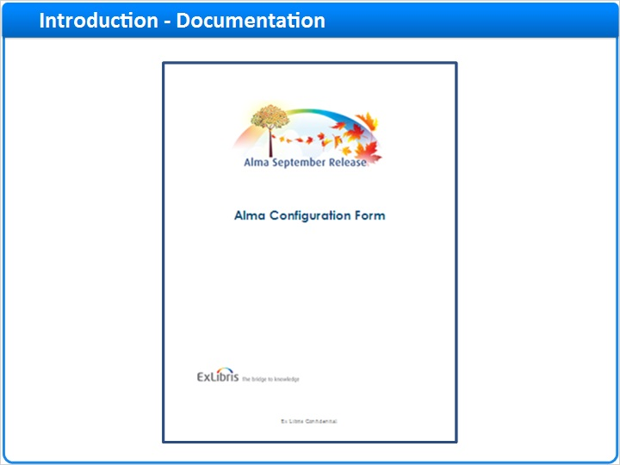
Notes:
Detailed instructions for completing the form are contained in a separate document, which you should have received from your Ex Libris team when you received the form.

1.5 Sample data
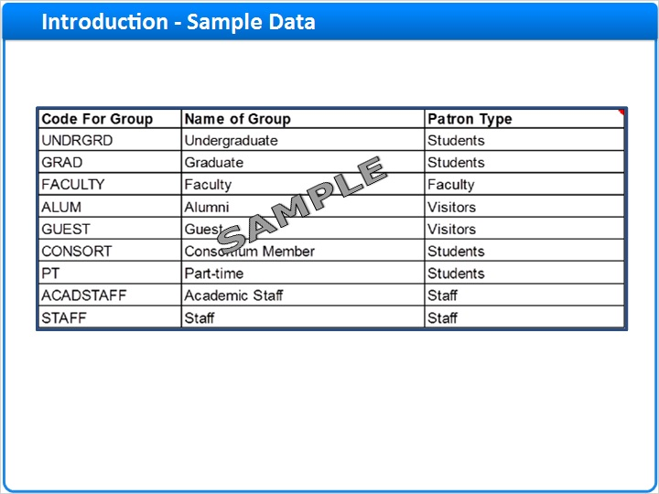
Notes:
A copy of the configuration form containing sample data, to better illustrate how to complete the form, is also included.

1.6 Default Values
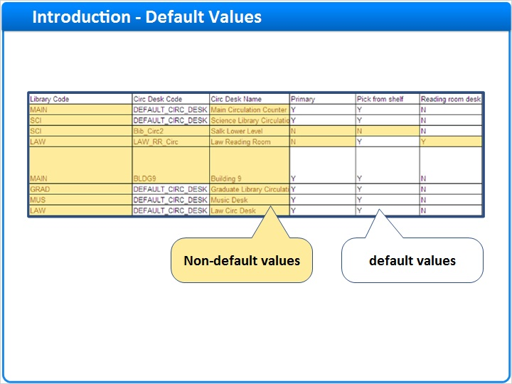
Notes:
Many parameters in Alma contain default values, which have been selected to reflect our best practice recommendations for most libraries. You may want to customize at least some of these parameters to meet your own needs. These default values are contained in the form, and non-default values are highlighted, in order to assist you in completing the form.
Please do not alter the structure of the configuration form, for example, by rearranging tabs, inserting new rows or columns, or inserting unsupported values in dropdowns. In addition, please do not copy/paste information into the form, since this often results in validation errors and corruption of the form.

1.7 Form Submission
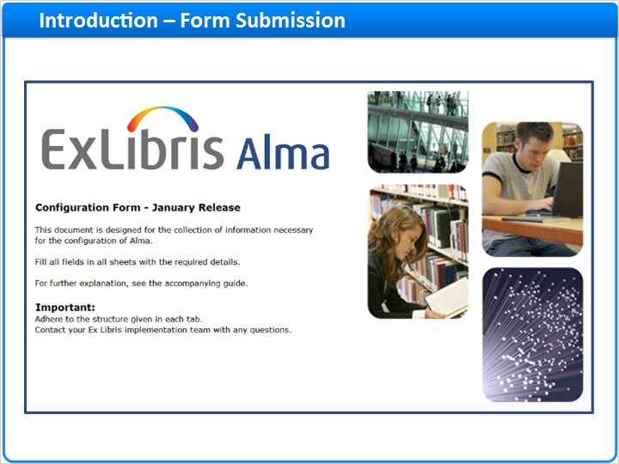
Notes:
Once the form has been completed and returned, your Ex Libris team will configure Alma according to the values you specified in the form. This is a one-time process designed to provide you with initial configuration. When this initial configuration is complete, you test Alma to verify the configurations and provide feedback concerning any necessary modifications. Your Ex Libris project team implements these modifications directly in Alma via the user interface. After your institution has completed Alma Certification Training, you are able to make such modifications yourself.

2. Alma_Configuration_Form

2.1 Configuration Form Tabs
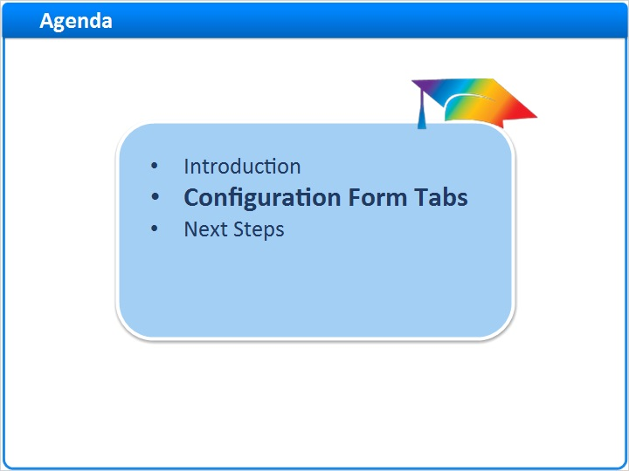
Notes:
Let’s move on to a discussion of the various tabs in the form. We will not discuss all tabs and tables, rather only those which we think warrant special attention. Please refer to the Customer Guide document which accompanies the configuration form for more information.

2.2 Fulfillment Tab – Type Tables
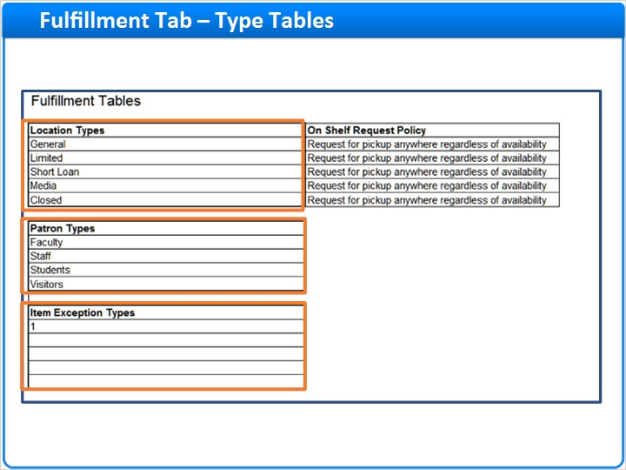
Notes:
The Fulfillment tab contains three mapping tables which are used by other tabs in the Configuration Form - Location Types, Patron Types and Item Exception Types. Let’s take a closer look at each of these. First the Location Types table.

2.3 Fulfillment Tab – Location Types
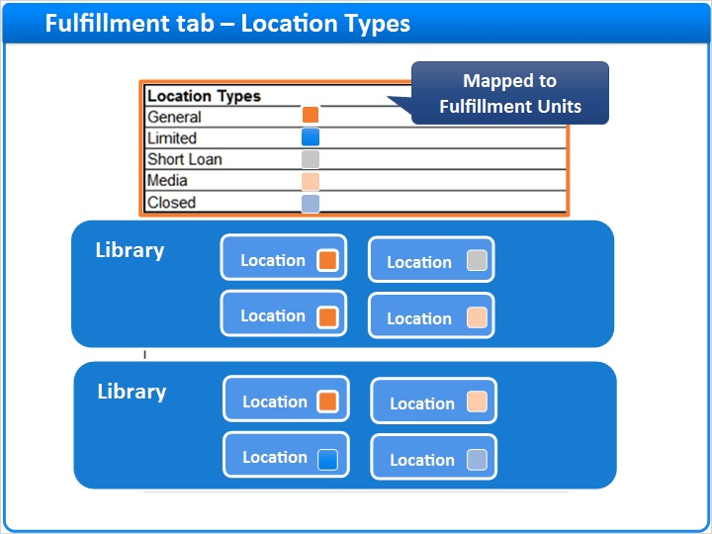
Notes:
As a reminder, Alma’s approach to fulfillment is location-based. Each location is categorized by type, and locations of the same type are grouped together into a fulfillment unit. In the Location Types table, you may define five different location types.
The values illustrated in this slide are a suggestion; you may select the values most suitable to the needs of your libraries.
Note that the location type parameter does not replace your locations. Rather, it is used only by the configuration form, in order to link your locations of a given type to a fulfillment unit.

2.4 Fulfillment Tab – Location Types
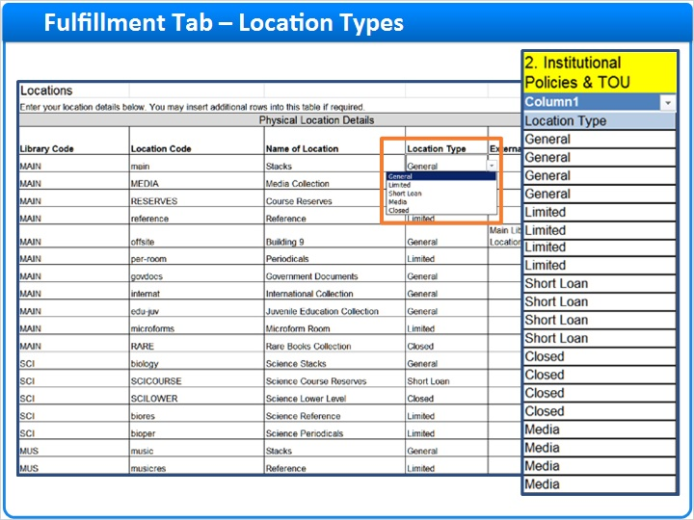
Notes:
In the Locations tab, you will map each one of your locations to one of the location types defined in the Fulfillment tab. The Configuration Form uses this Location Type value to gather your locations of a given type into a fulfillment unit.
In the Policies, TOU and Rules tab, you will use these location types in defining the loan and request policies which you want to apply to each location.

2.5 Fulfillment Tab - Patron Types
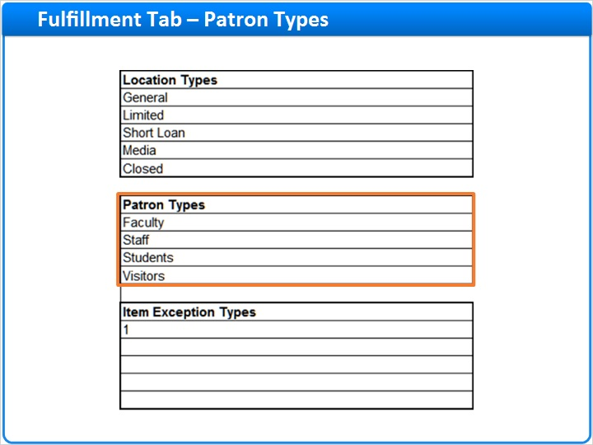
Notes:
In the Patron Types table, you may define four different patron types.
As in the Location Types table, the values illustrated here are a suggestion; you may change these to suit your own needs. Also, similarly to the location types, the patron types do not replace your patron groups. Rather they are used by the configuration form, in order to link your patron groups of a given type to loan and request policies.
The values you select here will appear in the Users tab, where you will map each of your patron groups to one of the patron types defined in this table.

2.6 Fulfillment Tab - Patron Types
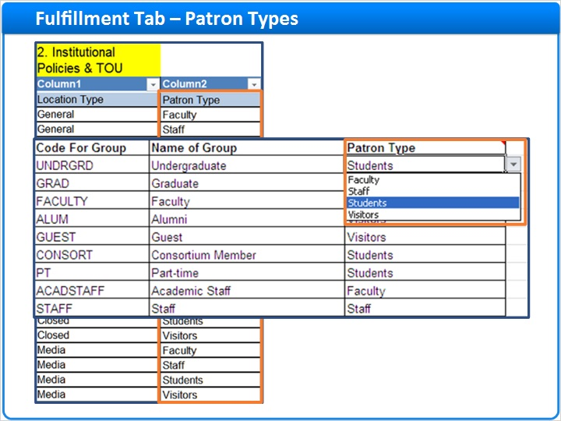
Notes:
In the Policies, TOU and Rules tab, you will use these patron types to define loan and request policies that you want to apply to each patron group for each location type.

2.7 Fulfillment Tab – Item Exception Types
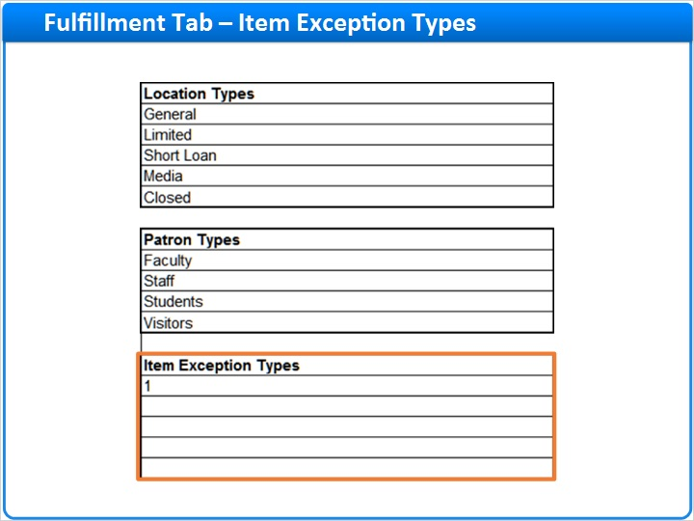
Notes:
In Alma’s location-based approach to fulfillment, item status is unnecessary for most items. Only if an item has loan or request policies that are exceptional to the other items in its location might you consider using item status.
In the Item Exception Types table, you may define up to five different item exception types.
The values illustrated here are a suggestion; you may change these values to suit the needs of your libraries.
The item exception type parameter does not replace your item statuses. Rather, it is used only by the configuration form, in order to link your item statuses of a given type to a fulfillment rule.
The values you define here will appear in the Item Policies tab, where you will map any item statuses you intend to use in Alma to one of the Item Exception Types.

2.8 Fulfillment Tab – Item Exception Types
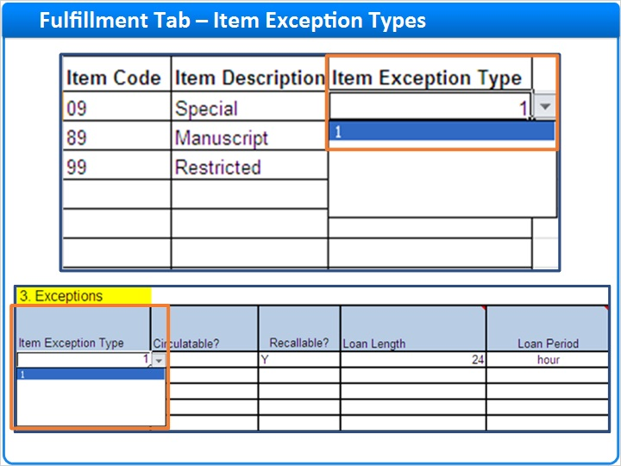
Notes:
The Item Exception Types also appear in the Policies, TOU and Rules tab, where you may use them to configure loan and request policies for exceptional items based on item status.

2.9 Libraries Tab
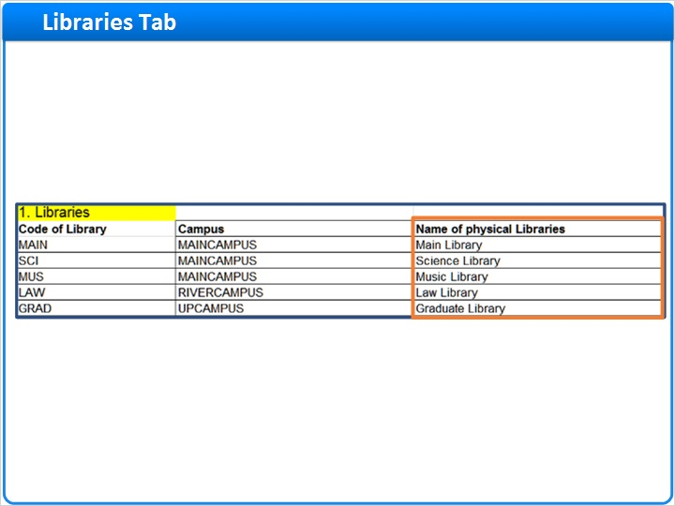
Notes:
The libraries tab contains information about your Alma libraries. These are the libraries that are created in Alma during the migration of data from your legacy system.
Use the ‘Name of physical libraries’ column if you want to change the name of the library as it will appear in Alma and in Primo.

2.10 Campus
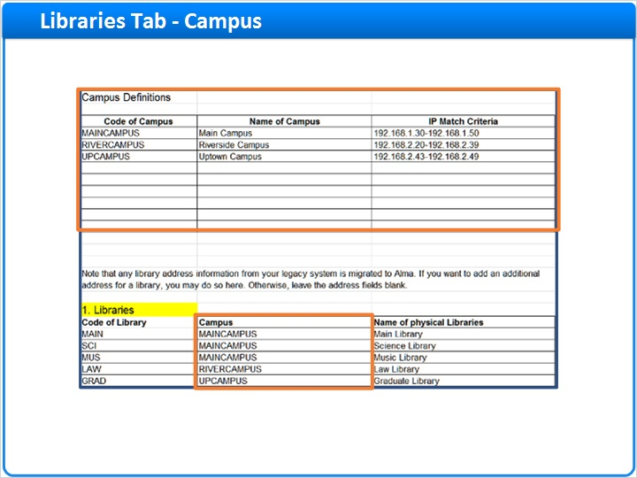
Notes:
You may use the Campus table to create one or more campuses in Alma. Campus is not a mandatory parameter, even if you have a multi-campus institution. The campus parameter can be useful in configuring your fulfillment policies and in restricting access to electronic resources.
You can associate your libraries with a campus by selecting the appropriate value from the dropdown list in the Campus field of the Libraries table.

2.11 Opening Hours
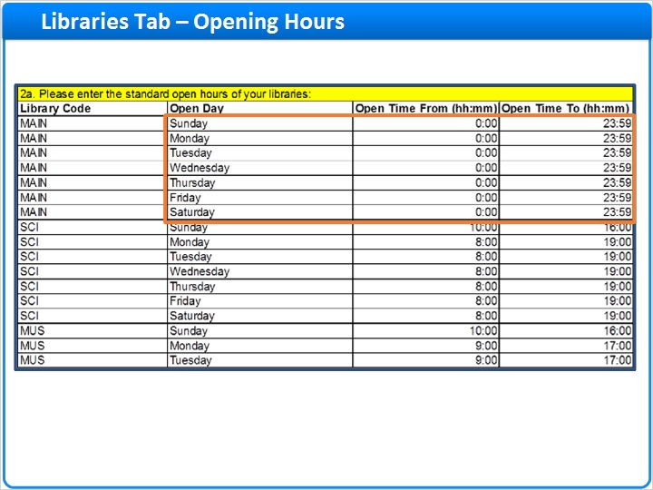
Notes:
The next three tables are dedicated to library calendars.
In the first of these tables, you define your standard opening hours. Each line contains the standard opening hours of a given library on a given day of the week. Enter standard open hours for each library for each open day on its own line. If your library is open until midnight, enter the ‘Open to’ time as 23:59. If your library is open past midnight, enter the hours past midnight in a separate row, with the ‘Open from’ time as 0:00. Remember that the value in the ‘Open Day’ column will then be for the following day of the week. In this example, we see that the Main Library is open 24 hours a day, 7 days a week.

2.12 Exceptional Open
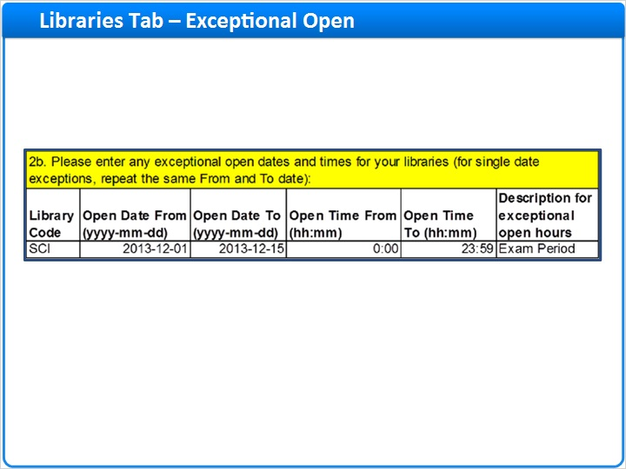
Notes:
In the next calendar table, enter dates and times of extended opening hours, for example during exam period. Note that times entered here do not override those in the previous table, but rather are in addition to them. So, for example, if your library has standard opening hours from 8:00 to 17:00, entering a row in this table for that library to define exceptional opening hours of 17:00 to 22:00, means that on that day, the library will be open from 8:00 to 22:00. Entering 8:00 to 22:00 in this table would have the same effect.
Note that exceptional opening hours that are shorter than standard opening hours, for example during semester breaks, must be configured in the following table.

2.13 Exceptional Closed
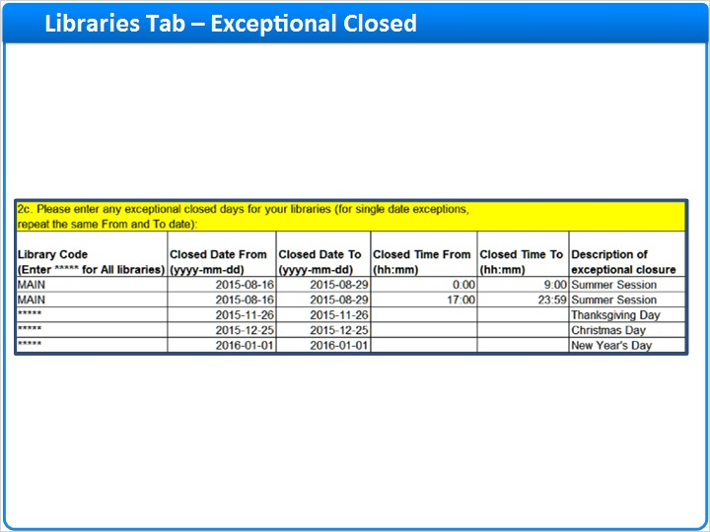
Notes:
The next table, table 2c, is used for any exceptional closed hours or days, that is, for hours or days on which the library is closed in exception to the standard open hours defined in table 2a. Alma can take closed hours and days into account when calculating due dates and overdue fines.
Times entered here are in addition to and take precedence over those in table 2a. For example, if your library has standard opening hours from 0:00 to 23:59, entering rows in this table for that library for exceptional closed hours of 0:00 to 9:00 and 17:00 to 23:59, as illustrated above, means that on that day or days, the library will be open from 9:00 to 17:00.
You may enter a single day exception by entering the same date in the ‘from’ and ‘to’ fields. Enter a date range if the library is closed on consecutive days. If no values are entered in the Closed Time From and Closed Time To fields, Alma will consider the library closed for the entire day on the dates entered.

2.14 Printers tab
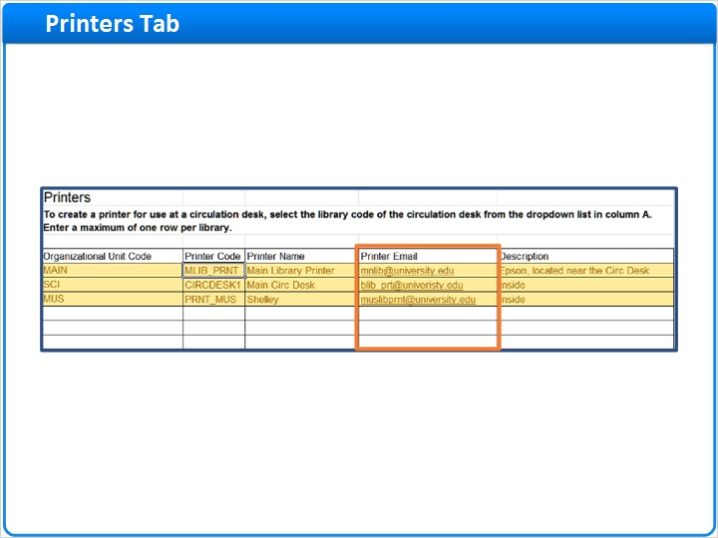
Notes:
The Printers Tab. Printers are used primarily at circulation desks, for example, to print hold slips and transfer slips. Alma does not make use of your computer’s native print functionality, which means that you must configure your network printers within Alma.
Alma sends notifications to be printed to the email address of the printer. If your printers do not support email, you can send your print jobs to an email address, and use 3rd-party email management software to send theses notifications from your email server to the appropriate network printer.

2.15 Circ Desks Tab – General Details
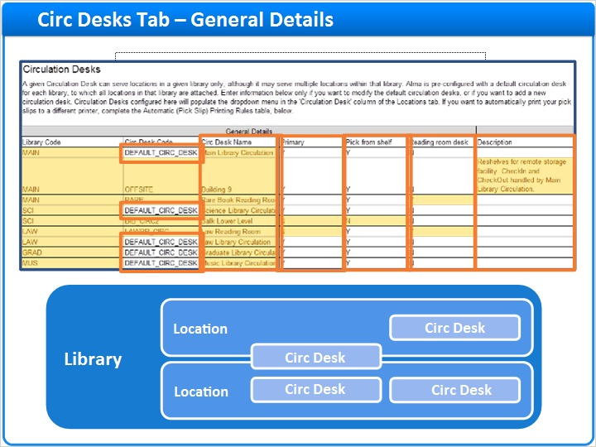
Notes:
At circulation desks, items can be checked-in (returned), checked-out (loaned), and re-shelved (items returned here can be placed back on the shelves without the need for further transit).
Circulation desks are defined per library and provide services to locations of that library. A library may have more than one circulation desk. A single circulation desk may serve more than one location, and a given location may be served by more than one circulation desk. But the circulation desk and the locations it serves must be in the same library.
A default circulation desk is automatically created for each library defined in Alma. Every location defined within that library is automatically linked to this default circulation desk and, by default, receives check-in, check-out, and reshelve services from this circulation desk. For this reason, you need to complete the Circ Desks tab only if you want to modify a default circulation desk (for example, to update the name) or to create a new circulation desk.
Our best practice recommendation is that you use the default circulation desk as the main circulation desk for the library. In libraries where only one circulation desk is required, we recommend that this be the default circulation desk. If required, however, you may define additional circulation desks in this tab. Note that a given circulation desk may appear in only one row in this table.
In the Library Code column, select the code of the library for which you want to create a new circulation desk or modify the default circulation desk.
In the ‘Circ Desk Code’ column, to modify an existing circulation desk, ensure that the Circulation Desk Code is <animate> ‘DEFAULT_CIRC_DESK’. To create a new circulation desk, enter a different code of up to 10 characters in length.
In the Circ Desk Name column, enter the name of the circulation desk as you want it to be displayed in Alma.
In the ‘Primary’ column, indicate whether items can be transited to this desk from other libraries, and from this desk to other libraries.

In the ‘Pick from shelf’ column, indicate whether this circulation desk will retrieve requested items from the shelf for locations served by this circ desk. If a given location is served by more than one circulation desk, only one of these circ desks should be responsible for retrieving on-shelf items that have been requested from that location.
In the ‘Reading room desk’ column, indicate whether this circulation desk provides services to a reading room. A reading room circulation desk is just like any other circulation desk, except that it has the additional ability of checking an item in and out multiple times to the same patron in the context of the same loan. Normally, when an item is checked-in, the loan is completed and the item is reshelved, or transited to the next pickup location if the item has been requested. A circulation desk with reading room functionality supports check-in without closing the loan. The checked-in item will be placed on the hold shelf for the patron for later use.
In the Description column, you can enter a description of the circulation desk.

2.16 Printer Code
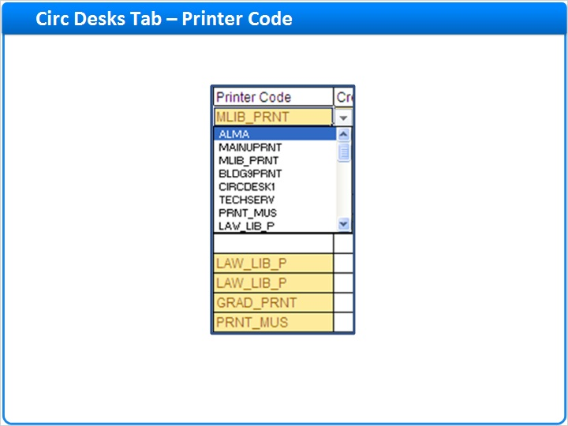
Notes:
In the Printer Code column select the printer that will serve this circulation desk. The dropdown here is populated with the list of printers you entered in the Printers tab. Ensure that the printer you select has been configured for the same library as that of the circulation desk.

2.17 Self Check Information
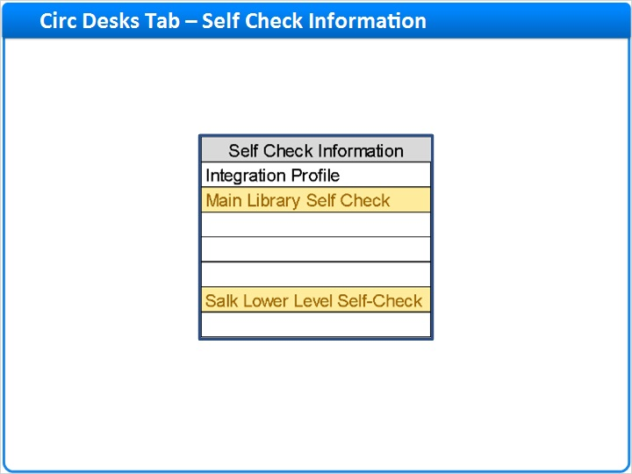
Notes:
Skipping to the end of this table, indicate whether a self-check machine is associated with this circ desk by entering the name of an integration profile for that self-check machine. Note that integration profiles are not part of the configuration form. Rather, you will need to create a self-check integration profile directly in Alma, via the General Configuration Menu, once you have access to your system. In the meantime, you can enter here the name of the integration profile you plan to configure later. Unique profiles must be created for every circulation desk with a self-check machine. You can, however, associate more than one self-check machine with a given circulation desk, as long as all machines provide identical services. Otherwise, each machine will require its own circ desk.

2.18 Automatic (Pick Slip) Printing Rules
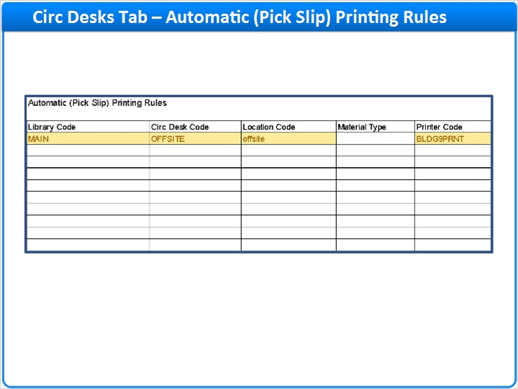
Notes:
Jumping down to the next table in the Circ Desks tab, here you can create rules to automatically print ‘pick from shelf’ slips for retrieval of items shelved in locations served by this circ desk. The rules allow you to print pick slips at the circ desk printer or at a remote printer (for example, in a remote storage location).

2.19 Pick from Shelf
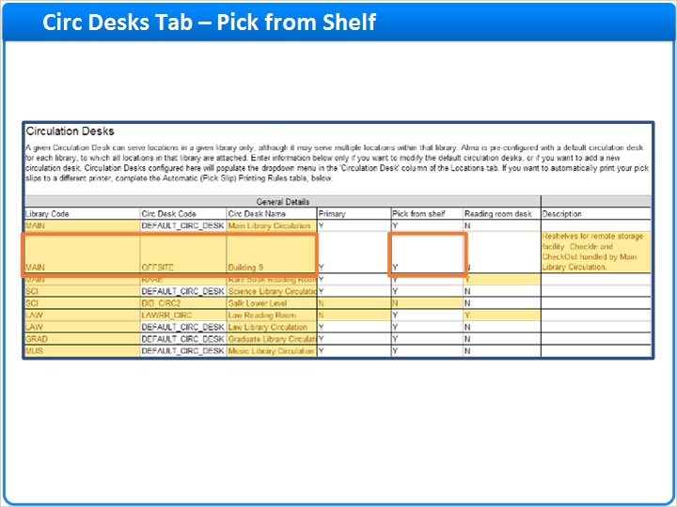
Notes:
Ensure that the circulation desk for which you have configured the print rule has the ‘Pick from Shelf’ parameter selected.

2.20 Locations Tab
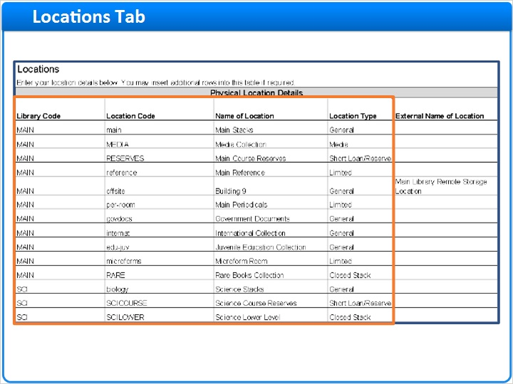
Notes:
The Locations tab contains information about the library locations created in Alma as a result of the migration of data from your legacy system. In this tab, you may update this information, if necessary.
In the Locations table, all library locations must be represented. However, only the first four <animate> columns are mandatory: Library code, Location code, Name of Location and Location Type.
The first three of these columns are pre-populated with data from your migration form. Please do not modify the data in the first two columns. You may, however, modify the third column to change the name of the location as you want it to be displayed in Alma.

2.21 Locations Tab
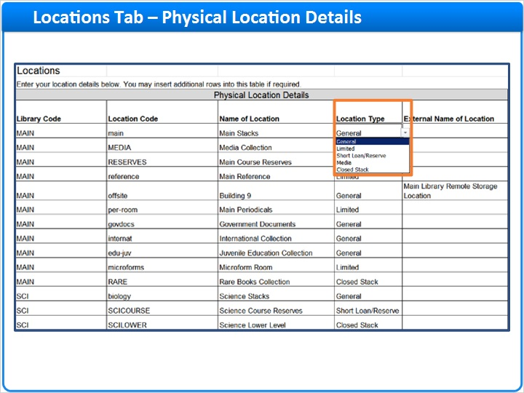
Notes:
The dropdown box in the location type column contains the values you entered in the Location Types table in the Fulfillment tab. Each location in this table should be mapped to one of these location types in order for that location to be included in a fulfillment unit. (Items in locations which are not part of any fulfillment unit cannot be requested, loaned or transited).

2.22 Physical Location Details
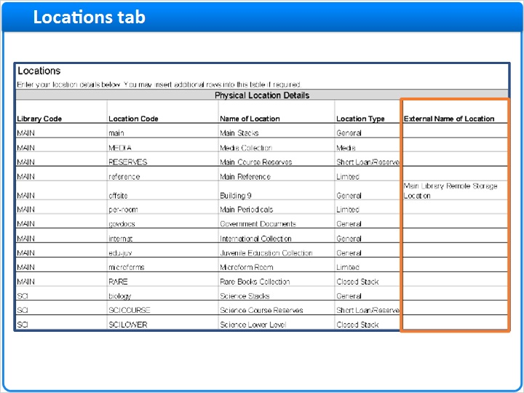
Notes:
In the External Name of Location column, enter the name of the location as you want it to be displayed in Primo. If no value is entered here, the value in the ‘Name of Location’ column will be displayed in Primo.
It is not necessary to complete the other columns in this table, unless you would like to modify the default configuration.

2.23 Physical Location Circ Desk Details
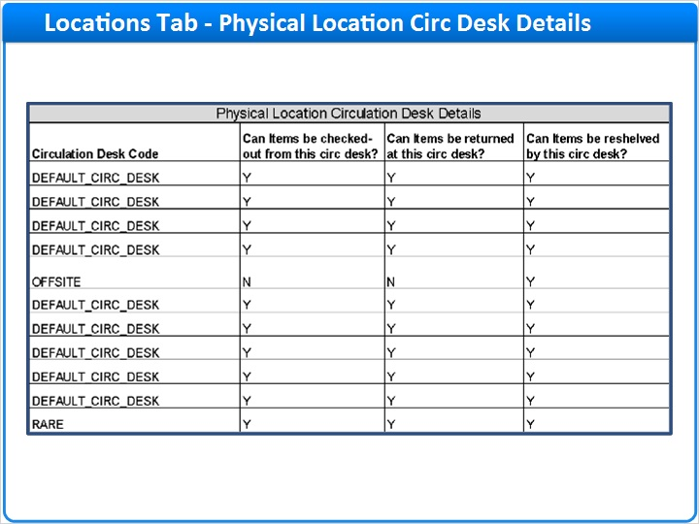
Notes:
In the next columns, you can modify the services provided to this location by the default circulation desk, or link a new circulation desk to this location.

2.24 Remote Storage Facilities
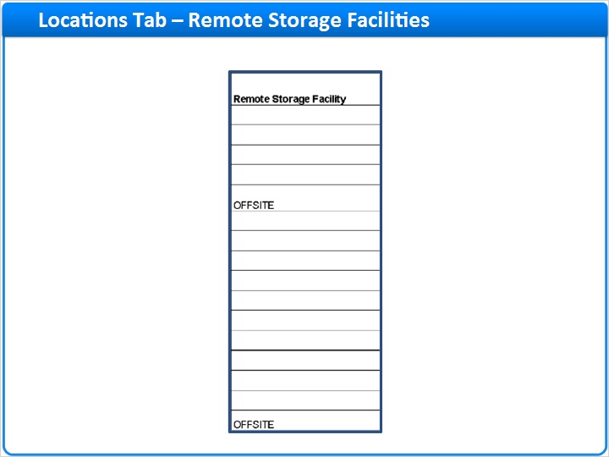
Notes:
The next column allows you to indicate that the location is a remote location, and should be linked to a Remote Storage Facility. Remote Storage Facilities are configured in the table at the bottom of the Locations tab.

2.25 Remote Storage Facilities
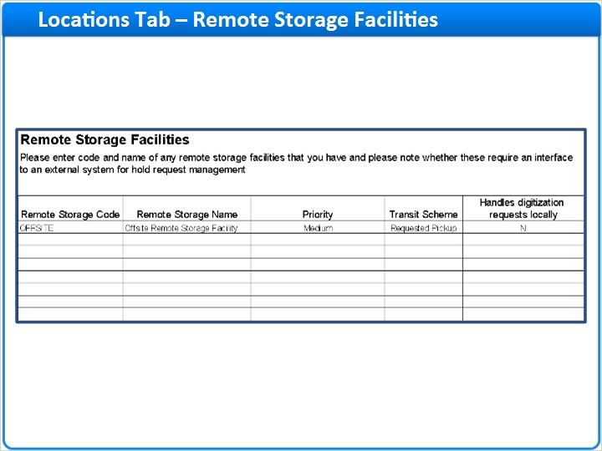
Notes:
You can use remote storage facilities in Alma to help you manage your remote locations. Remote locations are usually locations where you shelve low-use material. Remote locations are usually less accessible than other locations, perhaps they are offsite, and retrieving material from remote locations usually takes longer and may be more expensive than retrieving material from other locations.
If you associate a remote location with a Remote Storage Facility, by default, material in that location will always receive a lower priority than material in other locations. For example, if you hold 2 copies of a requested item, one in a location managed by a remote storage facility and one in some other location, when both copies are on shelf, Alma will try to fulfill the request with the non-remote storage copy first; the remote storage copy will be used only when there is no better alternative.
Remote Storage Facilities do not own locations in the way that libraries own locations. Rather, Remote Storage Facilities allow you to designate one or more locations from one or more libraries as ‘remote locations’. As explained, material in ‘remote locations’ receives lower priority, by default. In addition, you may configure Alma to send requests for material held in locations associated with the remote storage facility to a third-party system, such as a robotic retrieval system.

2.26 Locations Tab
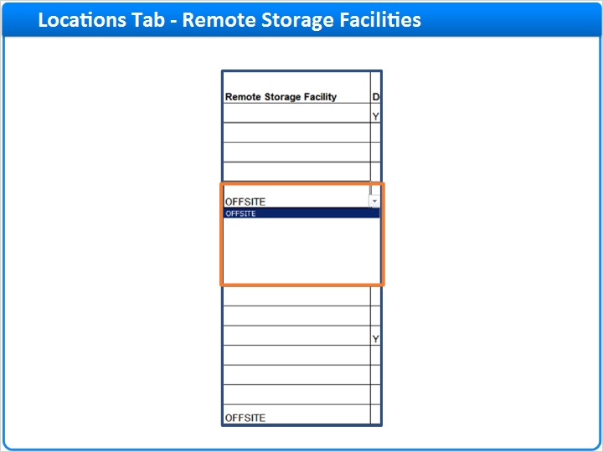
Notes:
After you have defined a Remote Storage Facility, you may associate any of your locations to it.

2.27 Call Number Type
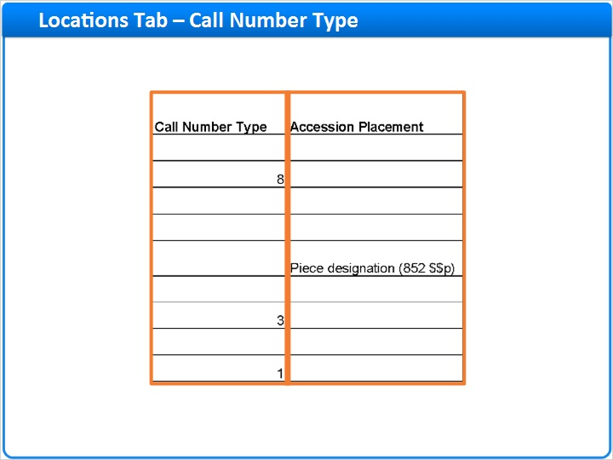
Notes:
Skipping now to the end of the locations table, select a value for the Call Number Type only if the location uses a call number type that is different than the institutional default, as defined by the call_number_type parameter in the General tab.
The call number type of a holdings record is determined by the value of the first indicator in MARC field 852. If this value is missing, the call number type for the holdings record is taken from the default value for the location and, if this value is missing, then from the institutional default value. Therefore, you should select a value in this field only if it differs from the institutional default.
Select a value for the Accession Placement only if you use accession numbers in that location. Note that defining an accession placement value will make that field mandatory for all holdings records in that location; you will not be able to save changes to holdings records in the Metadata Editor if the accession placement field in that record is empty.

2.28 Users Tab
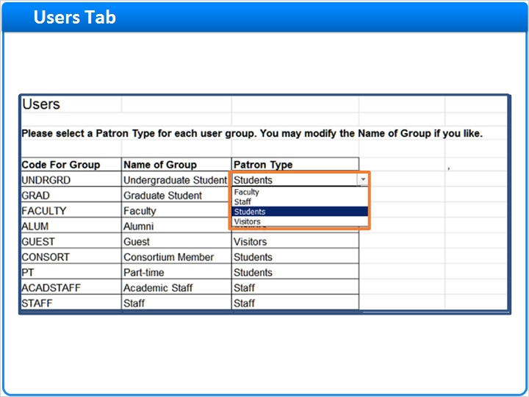
Notes:
Your users, together with their user group, are migrated from your legacy system. The Users table in the Users tab is pre-populated with those values.
The dropdown box in the patron type column contains the values you entered in the Patron Types table in the Fulfillment tab. Each user group you intend to use in Alma should be mapped to one of these patron types in order for that patron group to be included in a fulfillment rule.

2.29 Patron Limits
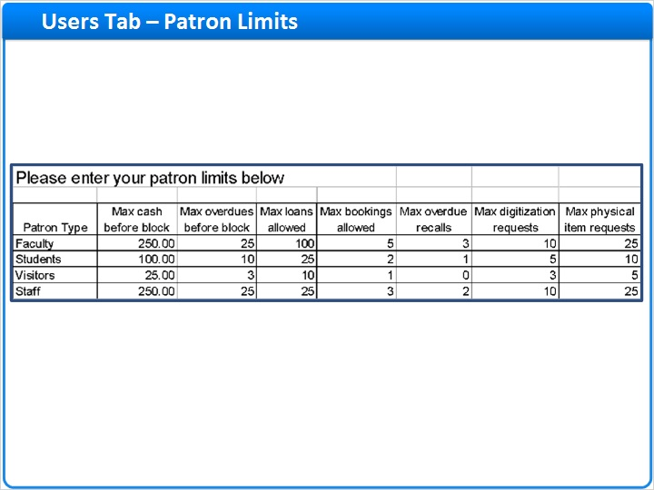
Notes:
Scroll down to the second table in this tab where you may define various library limits according to patron type. If a patron of this type exceeds any of the limits defined in this table, their borrowing, renewing and/or requesting privileges will be blocked.

2.30 Item Policies Tab
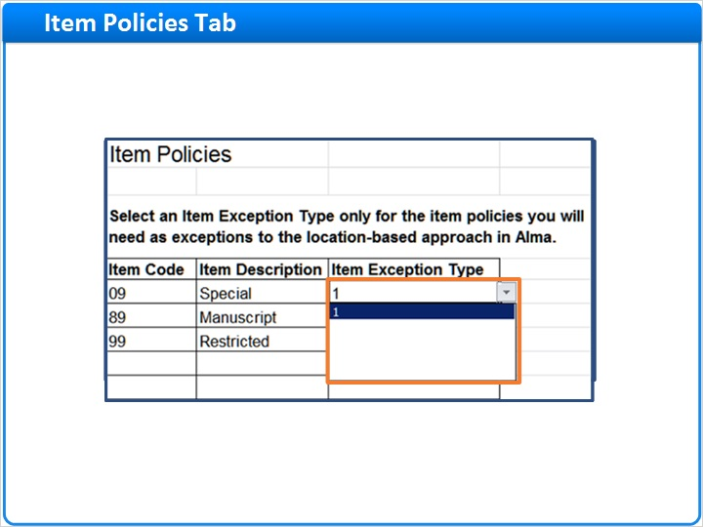
Notes:
The Item Policies tab contains item policies from your legacy system.

2.31 Policies, TOU & Rules Tab
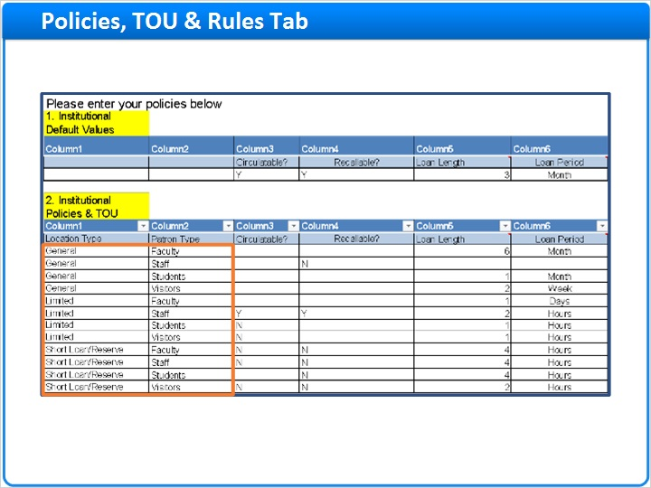
Notes:
The Policies, TOU & Rules tab defines the fulfillment units, associates the appropriate locations with each fulfillment unit, creates the fulfillment unit rules and terms of use.
The first two columns in each row in the second table are populated with each possible combination of the location types and patron types you selected in the Fulfillment tab.

2.32 Fulfillment Units
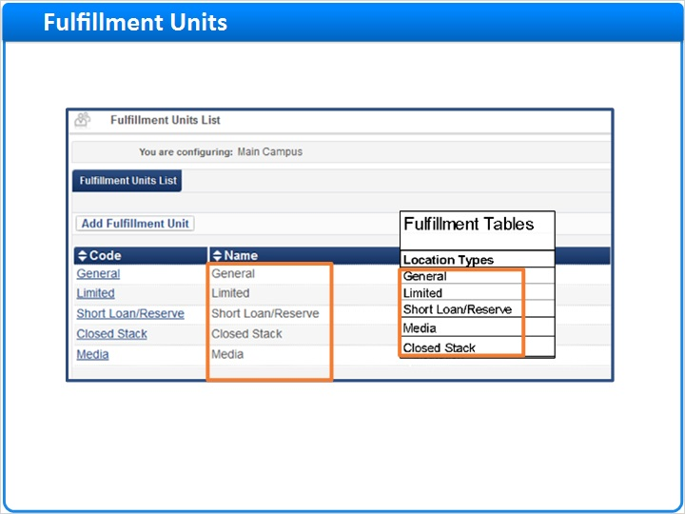
Notes:
One fulfillment unit will be created for each location type. Here, we can see the list of Fulfillment Units created in Alma as a result of the location type values in the Configuration Form. Notice that the names of the fulfillment units correspond to the names of the location types you defined in the form.

2.33 Fulfillment Units - Locations
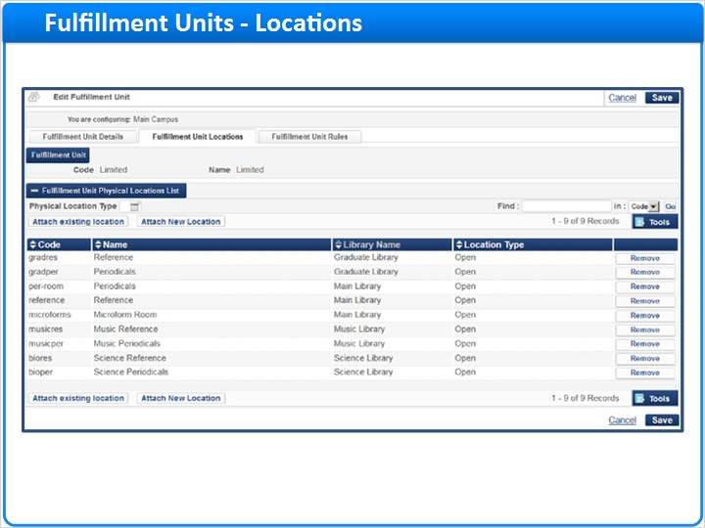
Notes:
Locations of the same type, as you defined in the Locations tab, have been included in the fulfillment unit of that type. Here we see a list of the Limited-type locations, which have been added to the Limited fulfillment unit.

2.34 Fulfillment Units – Rules
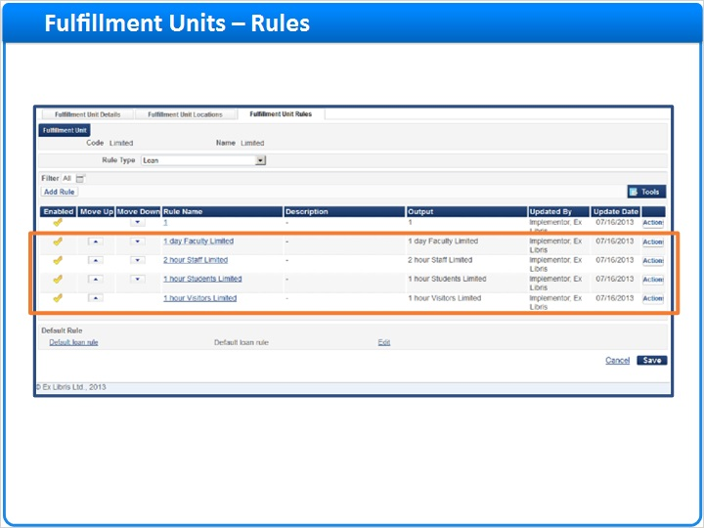
Notes:
Each fulfillment unit will contain a rule for each patron type, that is, for each row in the main Policies, TOU & Rules table.
Here, we see the rules that were created in Alma corresponding to the patron types that were defined in the form.

2.35 Fulfillment Units – Rules
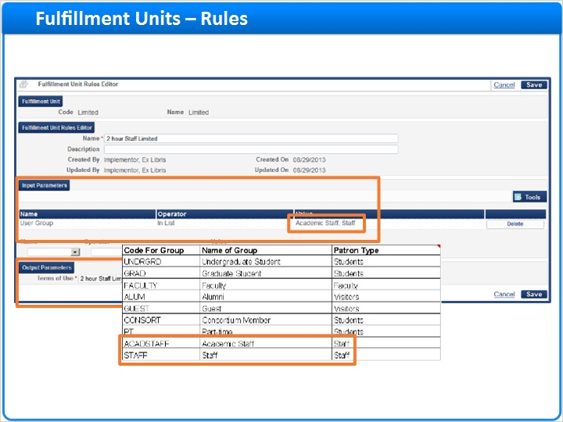
Notes:
Rules include two sections: the input section describes the scenario or conditions in which the rule will be applicable, for example, an item belonging to a location in the Limited fulfillment unit is to be loaned to a patron of user group Staff or Academic Staff. (Notice that these user groups have been included in a single rule by virtue of being mapped to the same Patron Type in the Users tab in the Configuration Form).
The second section of the fulfillment rule is the output section, which defines the terms of use, that is, the set of loan or request policies that will be applied to the scenario described by the input section.

2.36 TOU
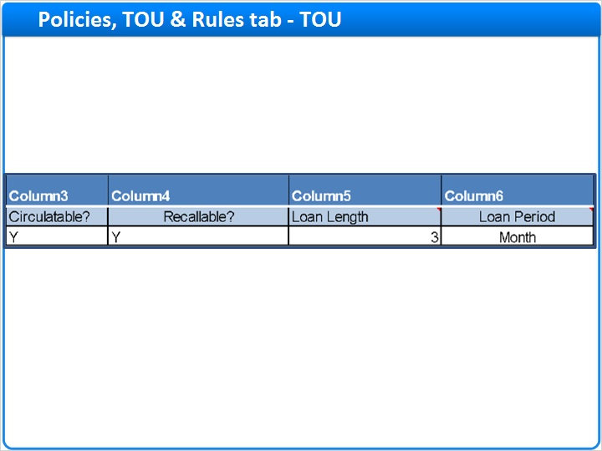
Notes:
The terms of use that will be applied by each rule, are defined in the remaining columns of each row. For example, the ‘Circulatable?’ column determines whether the item can be loaned; the ‘Recallable?’ column determines whether the loan may be recalled, etc. See the accompanying customer guide for a description of each of the policy columns.

2.37 TOU Details (Loan)
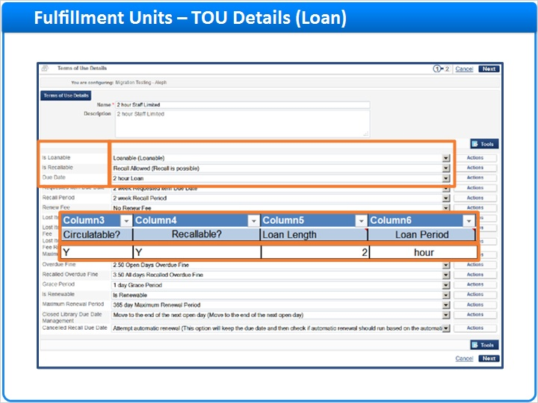
Notes:
Here you can see the Terms of Use which are applied for one of the rules. The left column corresponds to the column headings in the form.
And the right column corresponds to the specific values you select in each row.

2.38 Item Exceptions
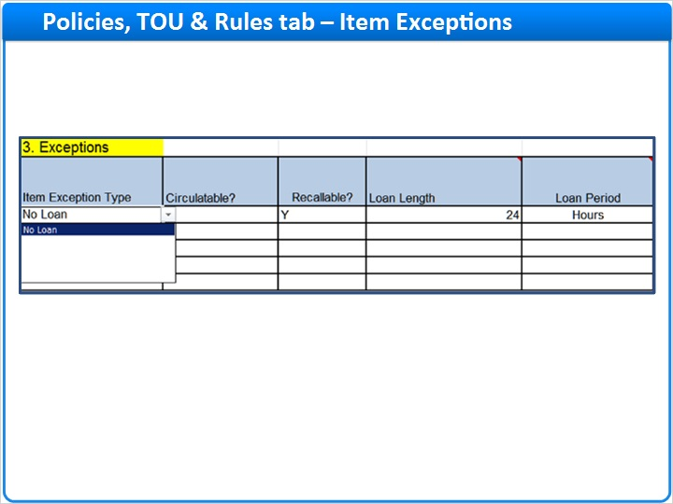
Notes:
If you require item-based exceptions to the location-based rules, you may enter these in table 3. Select the Item Exception Type from the list of values defined previously in the Fulfillment tab, and define the policies which should apply to that exception by completing the other columns in the row.

2.39 Fulfillment Units – Rules
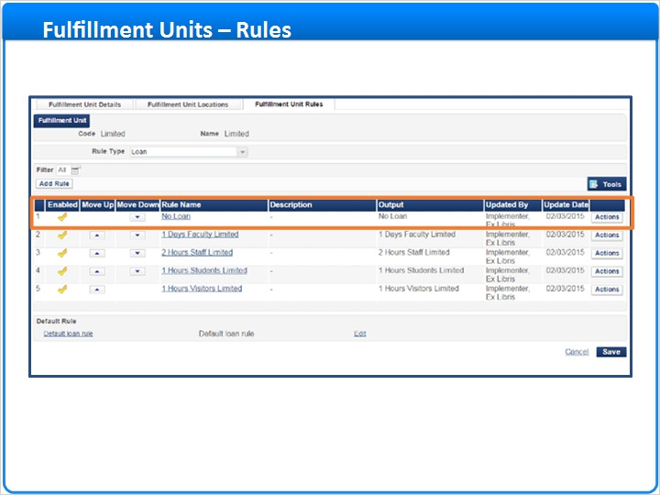
Notes:
Here we can see the item exception rule which was created in Alma.

2.40 Defaults Table
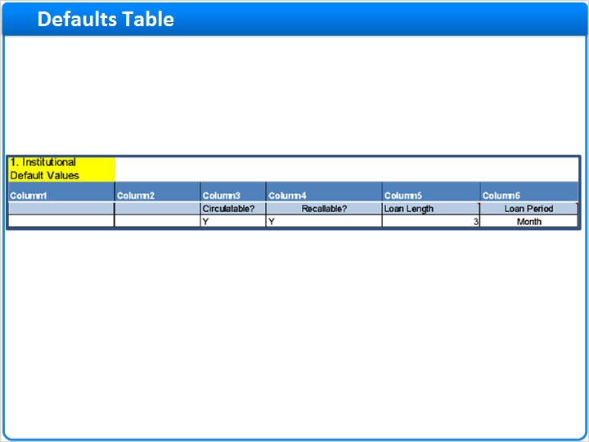
Notes:
Note that the first table in the Policies tab is mandatory. You must complete each column. Values in this table will be applied to any corresponding cells in the other tables that are left blank. In that respect, table 1 serves as a short-cut for completing the other tables in this tab. In the event that any cells in the other tables uses the same value as in table 1, you may leave that cell blank in the other tables; the corresponding value in table 1 will be applied.

2.41 Work Orders Tab
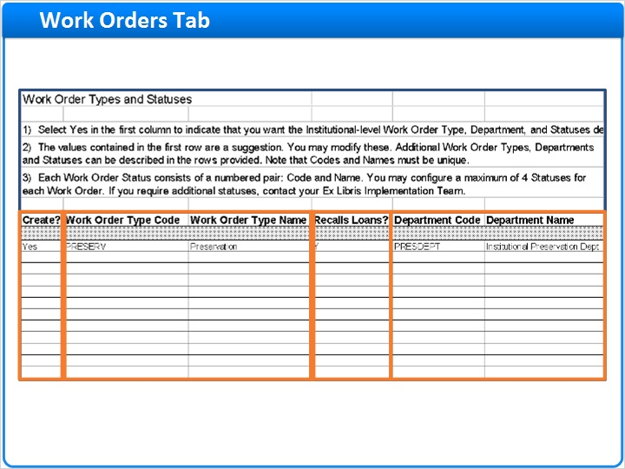
Notes:
Work Orders in Alma are not mandatory. They are designed to help you increase your level of inventory control when physical items are being processed in internal library departments such as binding, cataloging or preservation. Rather than simply placing a note on the shelf when removing an item for internal processing, creating a work order will update the status of the item in Alma. End users searching in Primo will see immediately that the item is not currently available. Library staff searching in Alma will see where the item may be found.
Use the Work Orders tab to configure work orders in Alma.
Work Orders in Alma have three components:
1. The Work Order Type
2. The Work Order Department
3. The Work Order Status
The Work Order Type represents the internal process the item is undergoing, for example, cataloging. The Work Order Department is the department in the institution to which the item is transited in order to undergo this process, for example, the Cataloging Department. And the Work Order Status represents the stage or status of the item in that process, for example, backlog, original cataloging, foreign language cataloging, copy cataloging, etc.
To create a new work order, select ‘Yes’ in the Create column. Enter a unique code and name for the work order type. Note that the code must be 10 characters or less.
Indicate whether work orders of this type should trigger a recall if the item requested for the work order is currently on loan.
Enter a unique code and name for the work order department. Note that a given work order type may have more than one department associated with it. However, a given department can be associated with only one work order type. If a department in your library handles more than one work order type, consider making one of the work order types a status, instead of its own work order.

2.42 Work Order Type
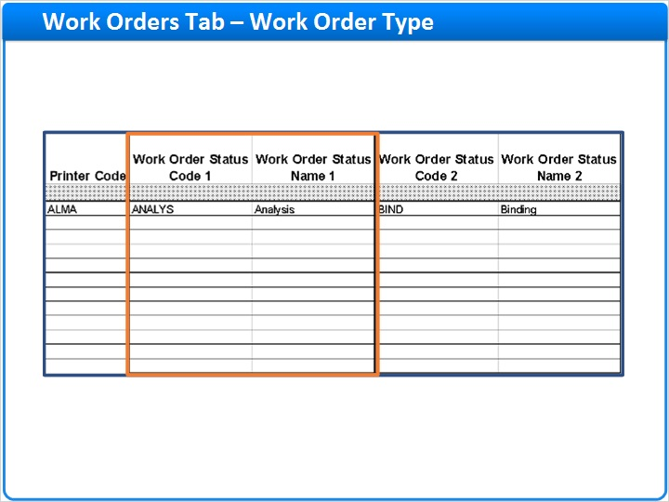
Notes:
Finally, enter a unique code and name for each of up to four work order statuses.

2.43 Summary and Next Steps
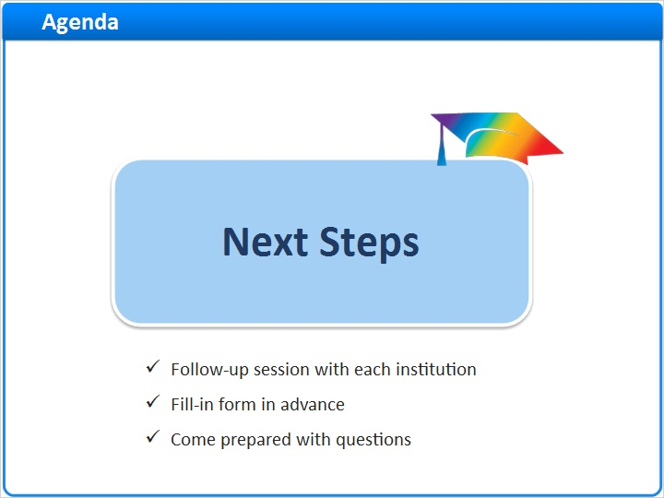
Notes:
This concludes our review of the Alma Configuration Form.
Your Ex Libris project team will be scheduling an individual session with your institution about one week before you must submit your configuration form. The purpose of this session is to answer any specific questions you may have about completing the form and to provide initial consultation and recommendations regarding best practices for your institution.

In preparation for that session, please complete as much of the configuration form as you can and formulate any questions in advance. Send your form ‘as is’ to your Ex Libris project team a day or two before the session, so that we may review it before our meeting with you.

2.44 Thank you!
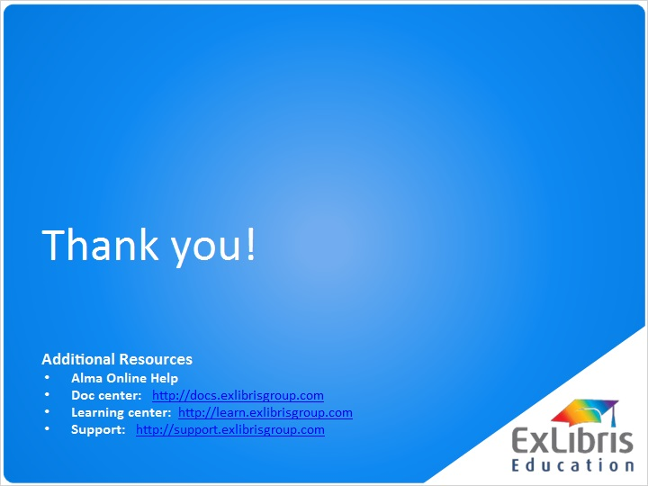
Notes:
Thank you for taking this lesson.
If you have any questions concerning the topics discussed after viewing this session, please refer them to your Ex Libris project team.
Also, you may want to search the Alma OLH to see if you can find answers to your questions there.

3. Untitled Scene

3.1 About this Training
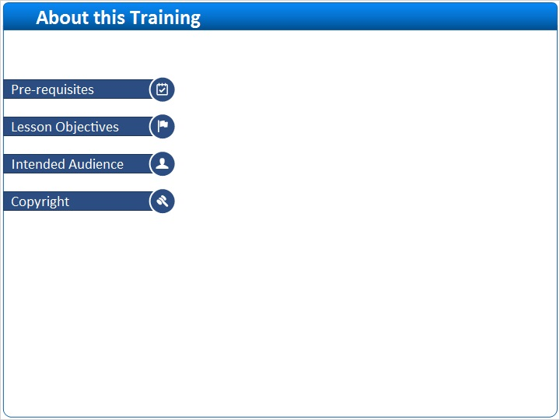
Notes:

1 (Slide Layer)
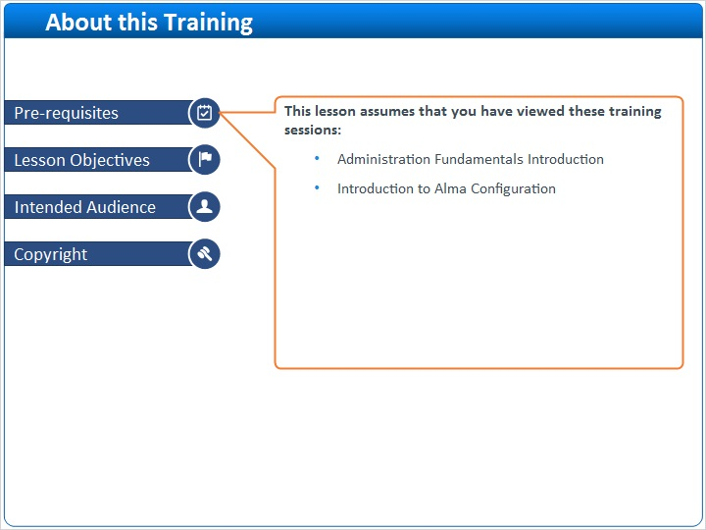

2 (Slide Layer)
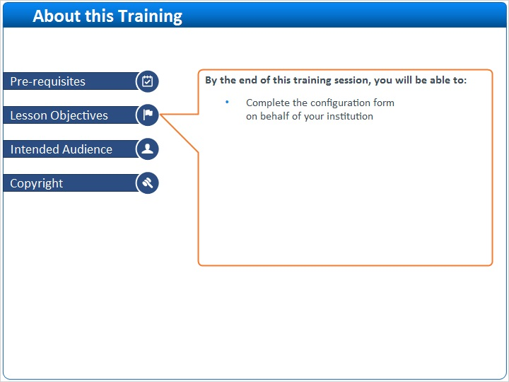

3 (Slide Layer)
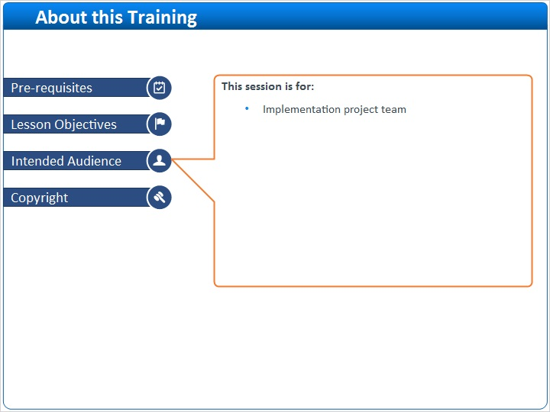

4 (Slide Layer)


